 | SVITLANA TARASENKO
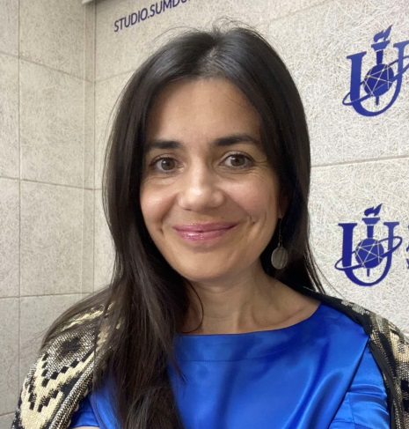 | PhD in Economic Sciences  Position: Associate Professor, Department of International Economic Relations, Sumy state University (Ukraine)
 | Tel: +380 (95) 5157232
 | E-mail: tarasenkosvitlana1@gmail.com

EDUCATIONAL BACKGROUND:

Since 2012 – PhD, Economics
2008 – 2011 – PhD Student
1999 – 2004- Sumy State University, Specialty «Economy of Firm»

WORK EXPERIENCE:

From 2018 till now:
Employer: Sumy State University
Position held: Department of International Economic Relations, Associate Professor

From 2021till 2022:
Employer: University of Social Sciences, Poland
Position held: Visiting Lecturer

From 2012 till 2017:
Employer: Sumy State University
Position held: Department of Social Medicine, Organization and Economy Healthcare Medical Institute, Senior Lecturer
ADDITIONAL INFORMATION:

Leadership in research and educational projects
- 2025-2026 - research project «Analyse the strategic priority-setting in research during crisis: optimising decision-making for societal resilience», "Ukrainian Science Centre of 'Excellence Science at risk", created within the framework of the grant program from the Alfred P. Sloan Foundation (IIE Program No.: SLNUK25000)
- 2024-2026 - Digitally-Enhanced Foreign Language Education for Active European Citizenship and Democratic Culture, KA220-HED, Erasmus+, Romania
- 2024-2026 - Disaster Resilience in Higher Education Systems via a Cloud University Model, KA220-HED, Erasmus+, Austria
- 2023-2025 - DialogEduShift: Transforming Higher Education Teaching and Evaluation Approaches in the Era of AI Chat Tools, KA220-HED, Erasmus+, Poland
- 2022-2023 - Kirkland Research Grant “Directions of Artificial Intelligence Implementation at Economy of Poland and Ukraine: To Build Back Better”, Poland
- 2022 - AI for Everyone, House of Europe
- 2022 - UNIDO/GCIP Ukraine Global Cleantech Innovation Program in Ukraine
- 2021 - Roadmap for Prevention of Oncological Gynecological Diseases in the Sumy region, Analytical study, International Foundation «Renaissance», with the financial support of OSIFE, Embassy of Sweden in Ukraine
- 2020-2022 - GAMEON - The Introduction Journey to the Game Industry for NEETs, KA205 - Strategic Partnerships for Youth, Erasmus, Poland
- 2020-2022 - Patostreaming" - Counteracting Pathological Cyber Streaming Attitudes Amongst Youth KA205, Strategic Partnerships Youth, Erasmus, Poland
- 2020-2021 - Promoting Gender Equality and Empowering Women in the Decentralization Reform in Ukraine, United Nation Women in Ukraine
- 2018 - Civic Cinema: Creativity as a Civil Action Project, DVV International with the support of the German Ministry of Foreign Affairs
- 2017 - School of Civil Urban Studies: Case of Sumy, DVV International with the support of the German Ministry of Foreign Affairs

Awards
- 2022 - Resilience Award, Leipzig University and Automotive Cluster Ostdeutschland, scientific work titled: “And No Just-in-time For All”
- 2009 - Winner «Innovative Intellect of Ukraine»
Membership
- Member of Eastern European Association for Civic Education (EENCE) (from 2023)

